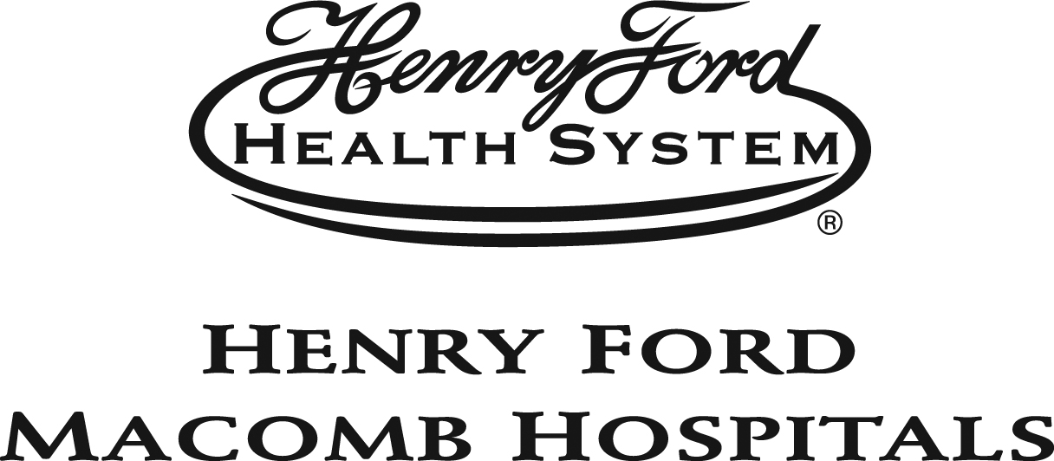
October 9, 2020
MACOMB COUNTY ANNOUNCES #MASKUPMACOMB POSTER DESIGN CONTEST WINNERS
In recognition of the importance of wearing a mask to reduce the spread of COVID-19, Macomb County called out to resident creatives of all ages to design a poster to help promote #MaskUpMacomb. Artists responded with a variety of impressive original designs.

The final results are as follows:
YOUTH
- First Place: Isabella Dalecke, age 16, "We Are Stronger Together", Digital art, from St. Clair Shores, MI.
- Second Place: Meadow VanArman, age 15, "Staying Safe", Digital art, from Sterling Heights, MI.
- Third Place: Thy Hoang, age 16, "WEAR A MASK", Digital art, from Sterling Heights, MI.

ADULT
- First Place (Printed Poster & $500): Vanessa Montano, "Mask Up!", Digital art, from Macomb, MI.
- Second Place ($250): Melanie Craik, "#MaskUpMacomb", Digital art, from St. Clair Shores, MI.
- Third Place ($150): Donna Hurt, "We Are Macomb", Digital art, from Sterling Heights, MI.

“I was particularly moved by many of the children and teen entrants who were tackling issues in their art beyond the need for a mask,” says juror, Mallory Montgomery, from Henry Ford Cancer Institute. “My selections for this contest not only reflect the diverse people who live in Macomb County, but also hope to inspire those at most risk of not wearing a mask. It is my sincerest wish that you see yourself in this art and are moved with compassion, empathy, and love to help protect our community.”
A panel of judges from each organization reviewed the entries based on originality, distinctive design, and its ability to convey the message that face coverings are an important way to protect public health. All entries were viewed and judged randomly and anonymously to ensure unbiased and fair judging.

"Residents of Macomb County see and understand the importance of wearing a mask—the art submissions made that clear,” says juror Natalie Dean-Wood of the Macomb County Health Department. “As a health professional, it was encouraging and hopeful to see the knowledge of the artists come out in their designs."

Sponsored by Macomb County in partnership with the Anton Art Center and Henry Ford Macomb Hospitals, entries were accepted online (www.theartcenter.org/artist-opportunities) August 26th through an extended deadline of September 30th at midnight. The contest is awarding prizes for the top three in each act category: those above the age of 18 and those below the age of 18.

“Art programs like the #MaskUpMacomb design contest offer artists an opportunity to participate and compete for prizes, while the top design will provide the community with an important message,” adds juror Stephanie Hazzard of the Anton Art Center. “Macomb County residents certainly did their part to make this new public health campaign a success!”

The top entry in the adult category is being printed as a poster and distributed in communities across Macomb County. The creator of the top design in the adult age category is receiving a cash prize of $500, with $250 awarded to the second place design and $150 for the third. The top three entries in the youth category are receiving one complimentary registration for an art class offered at the Anton Art Center in downtown Mount Clemens.

Each of the top six designs will be available for download, here (www.theartcenter.org/exhibits).
###

#MaskUpMacomb Images (6)
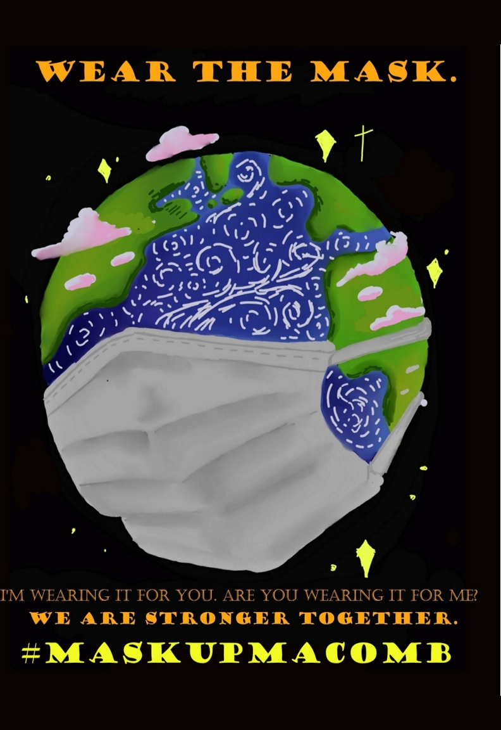  First Place, Youth: Isabella Dalecke, age 16, "We Are Stronger Together", Digital art, from St. Clair Shores, MI. | 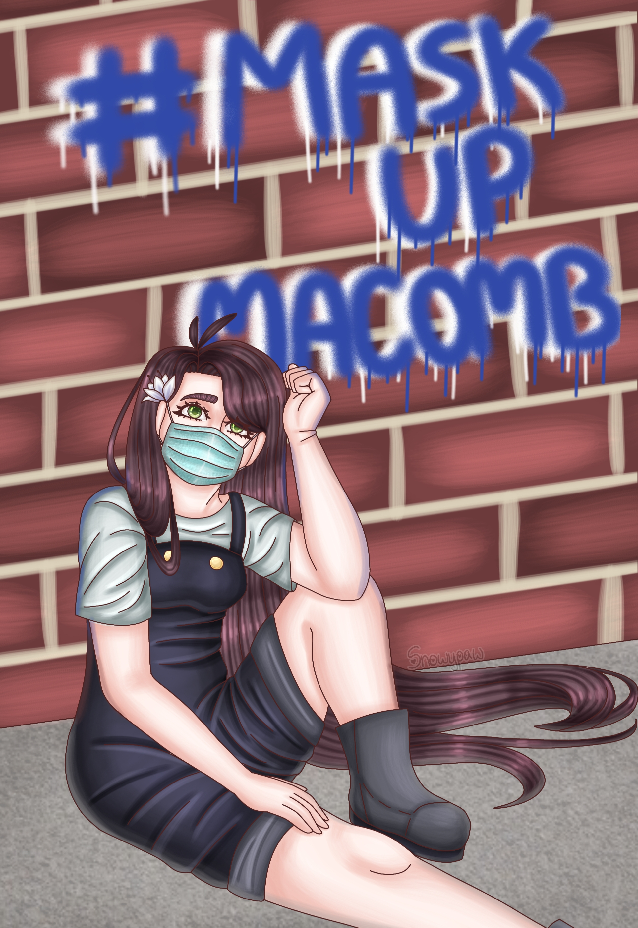  Second Place, Youth: Meadow VanArman, age 15, "Staying Safe", Digital art, from Sterling Heights, MI. | 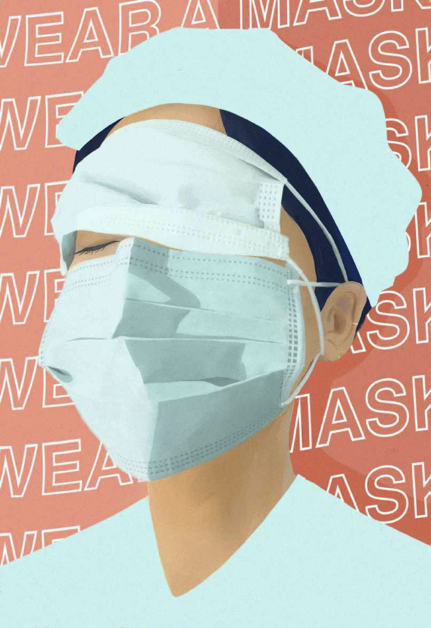  Third Place, Youth: Thy Hoang, age 16, "WEAR A MASK", Digital art, from Sterling Heights, MI.
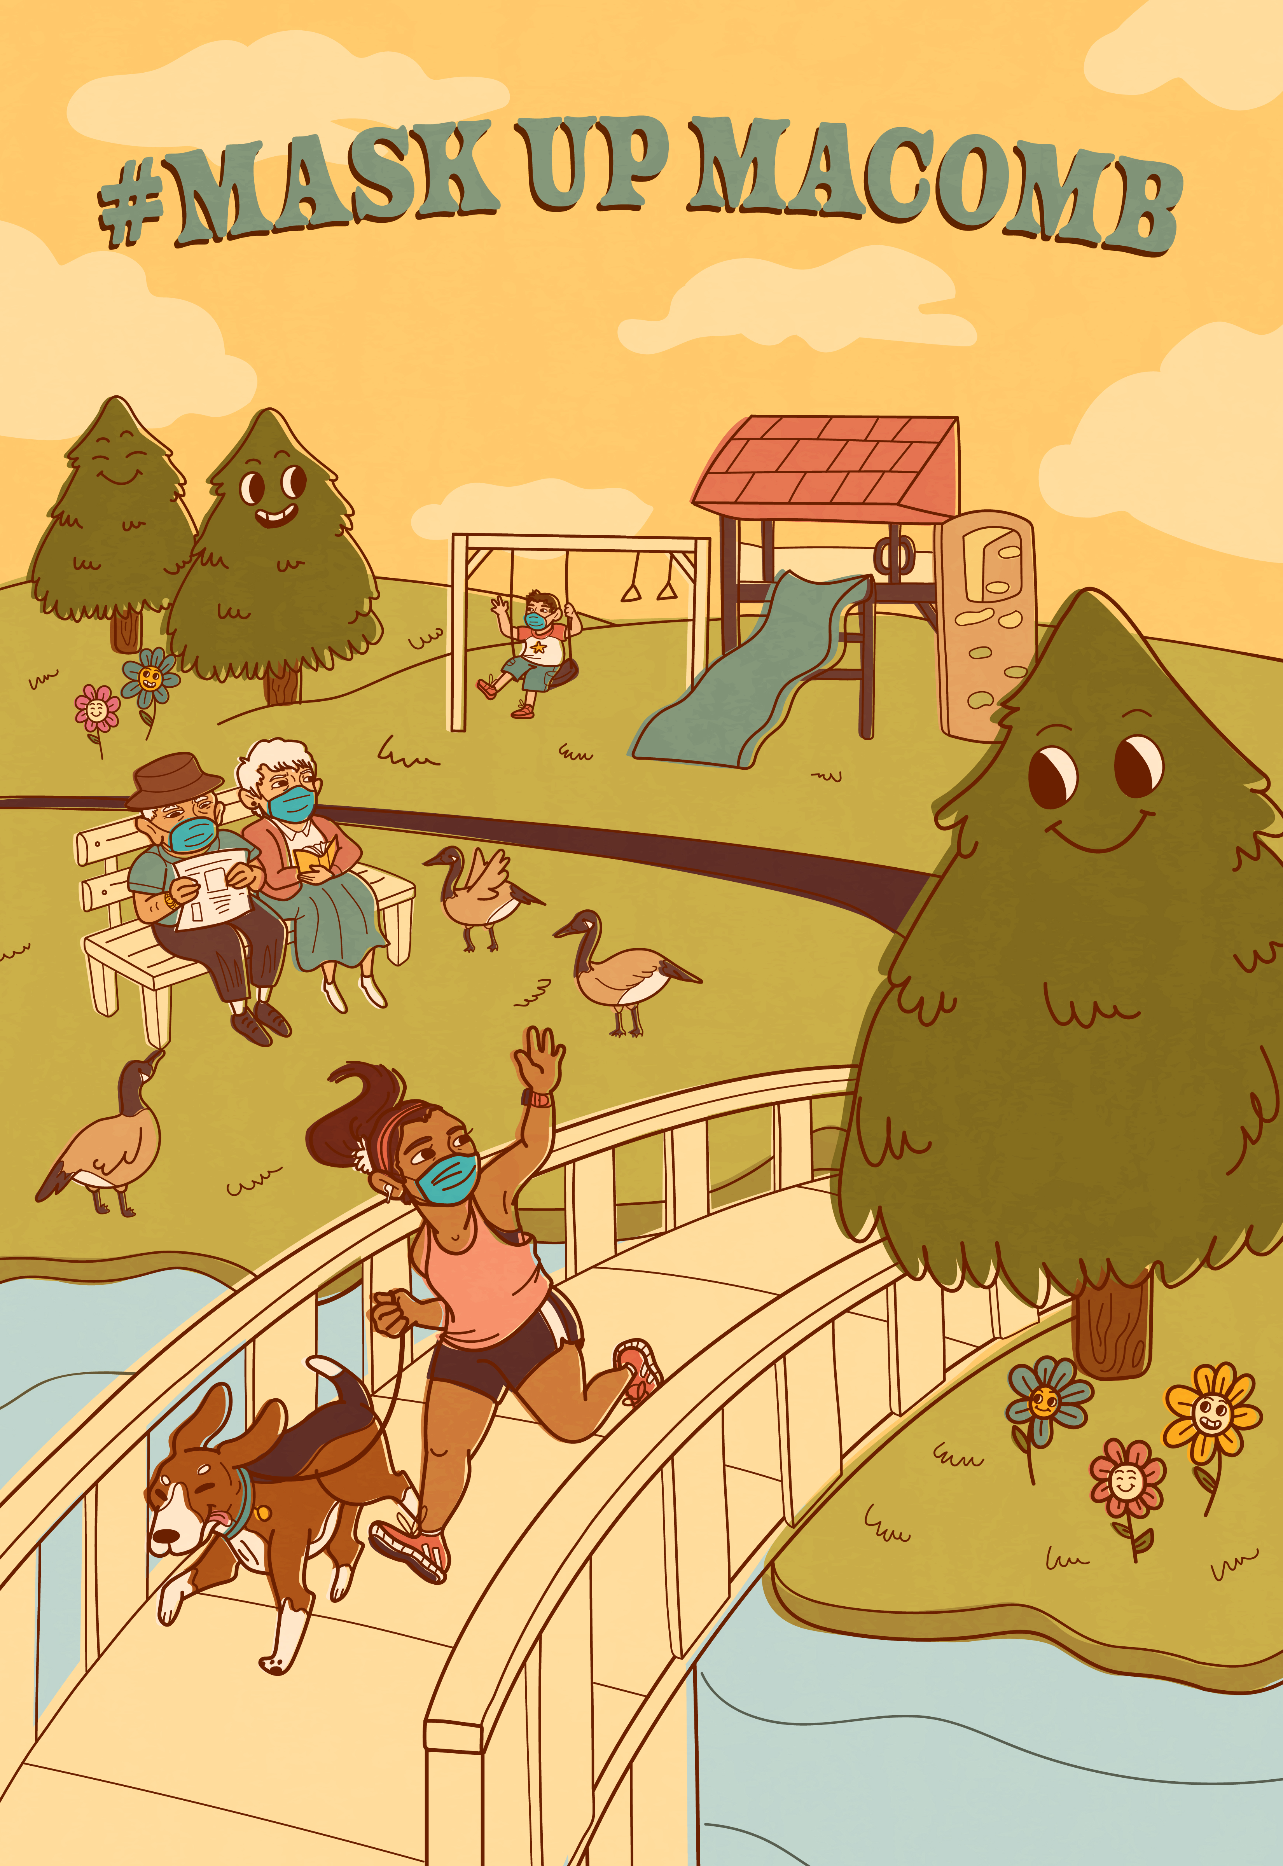  First Place, Adult: Vanessa Montano, "Mask Up!", Digital art, from Macomb, MI. | 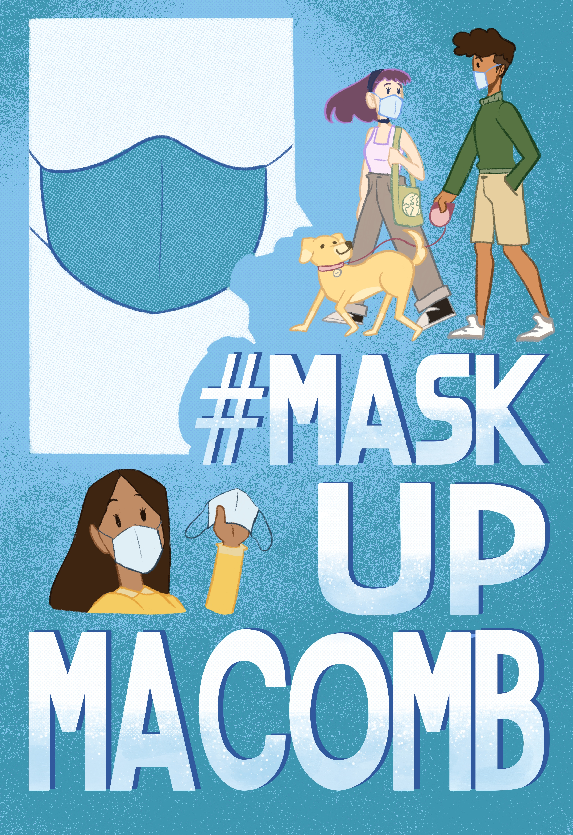  Second Place, Adult: Melanie Craik, "#MaskUpMacomb", Digital art, from St. Clair Shores, MI. | 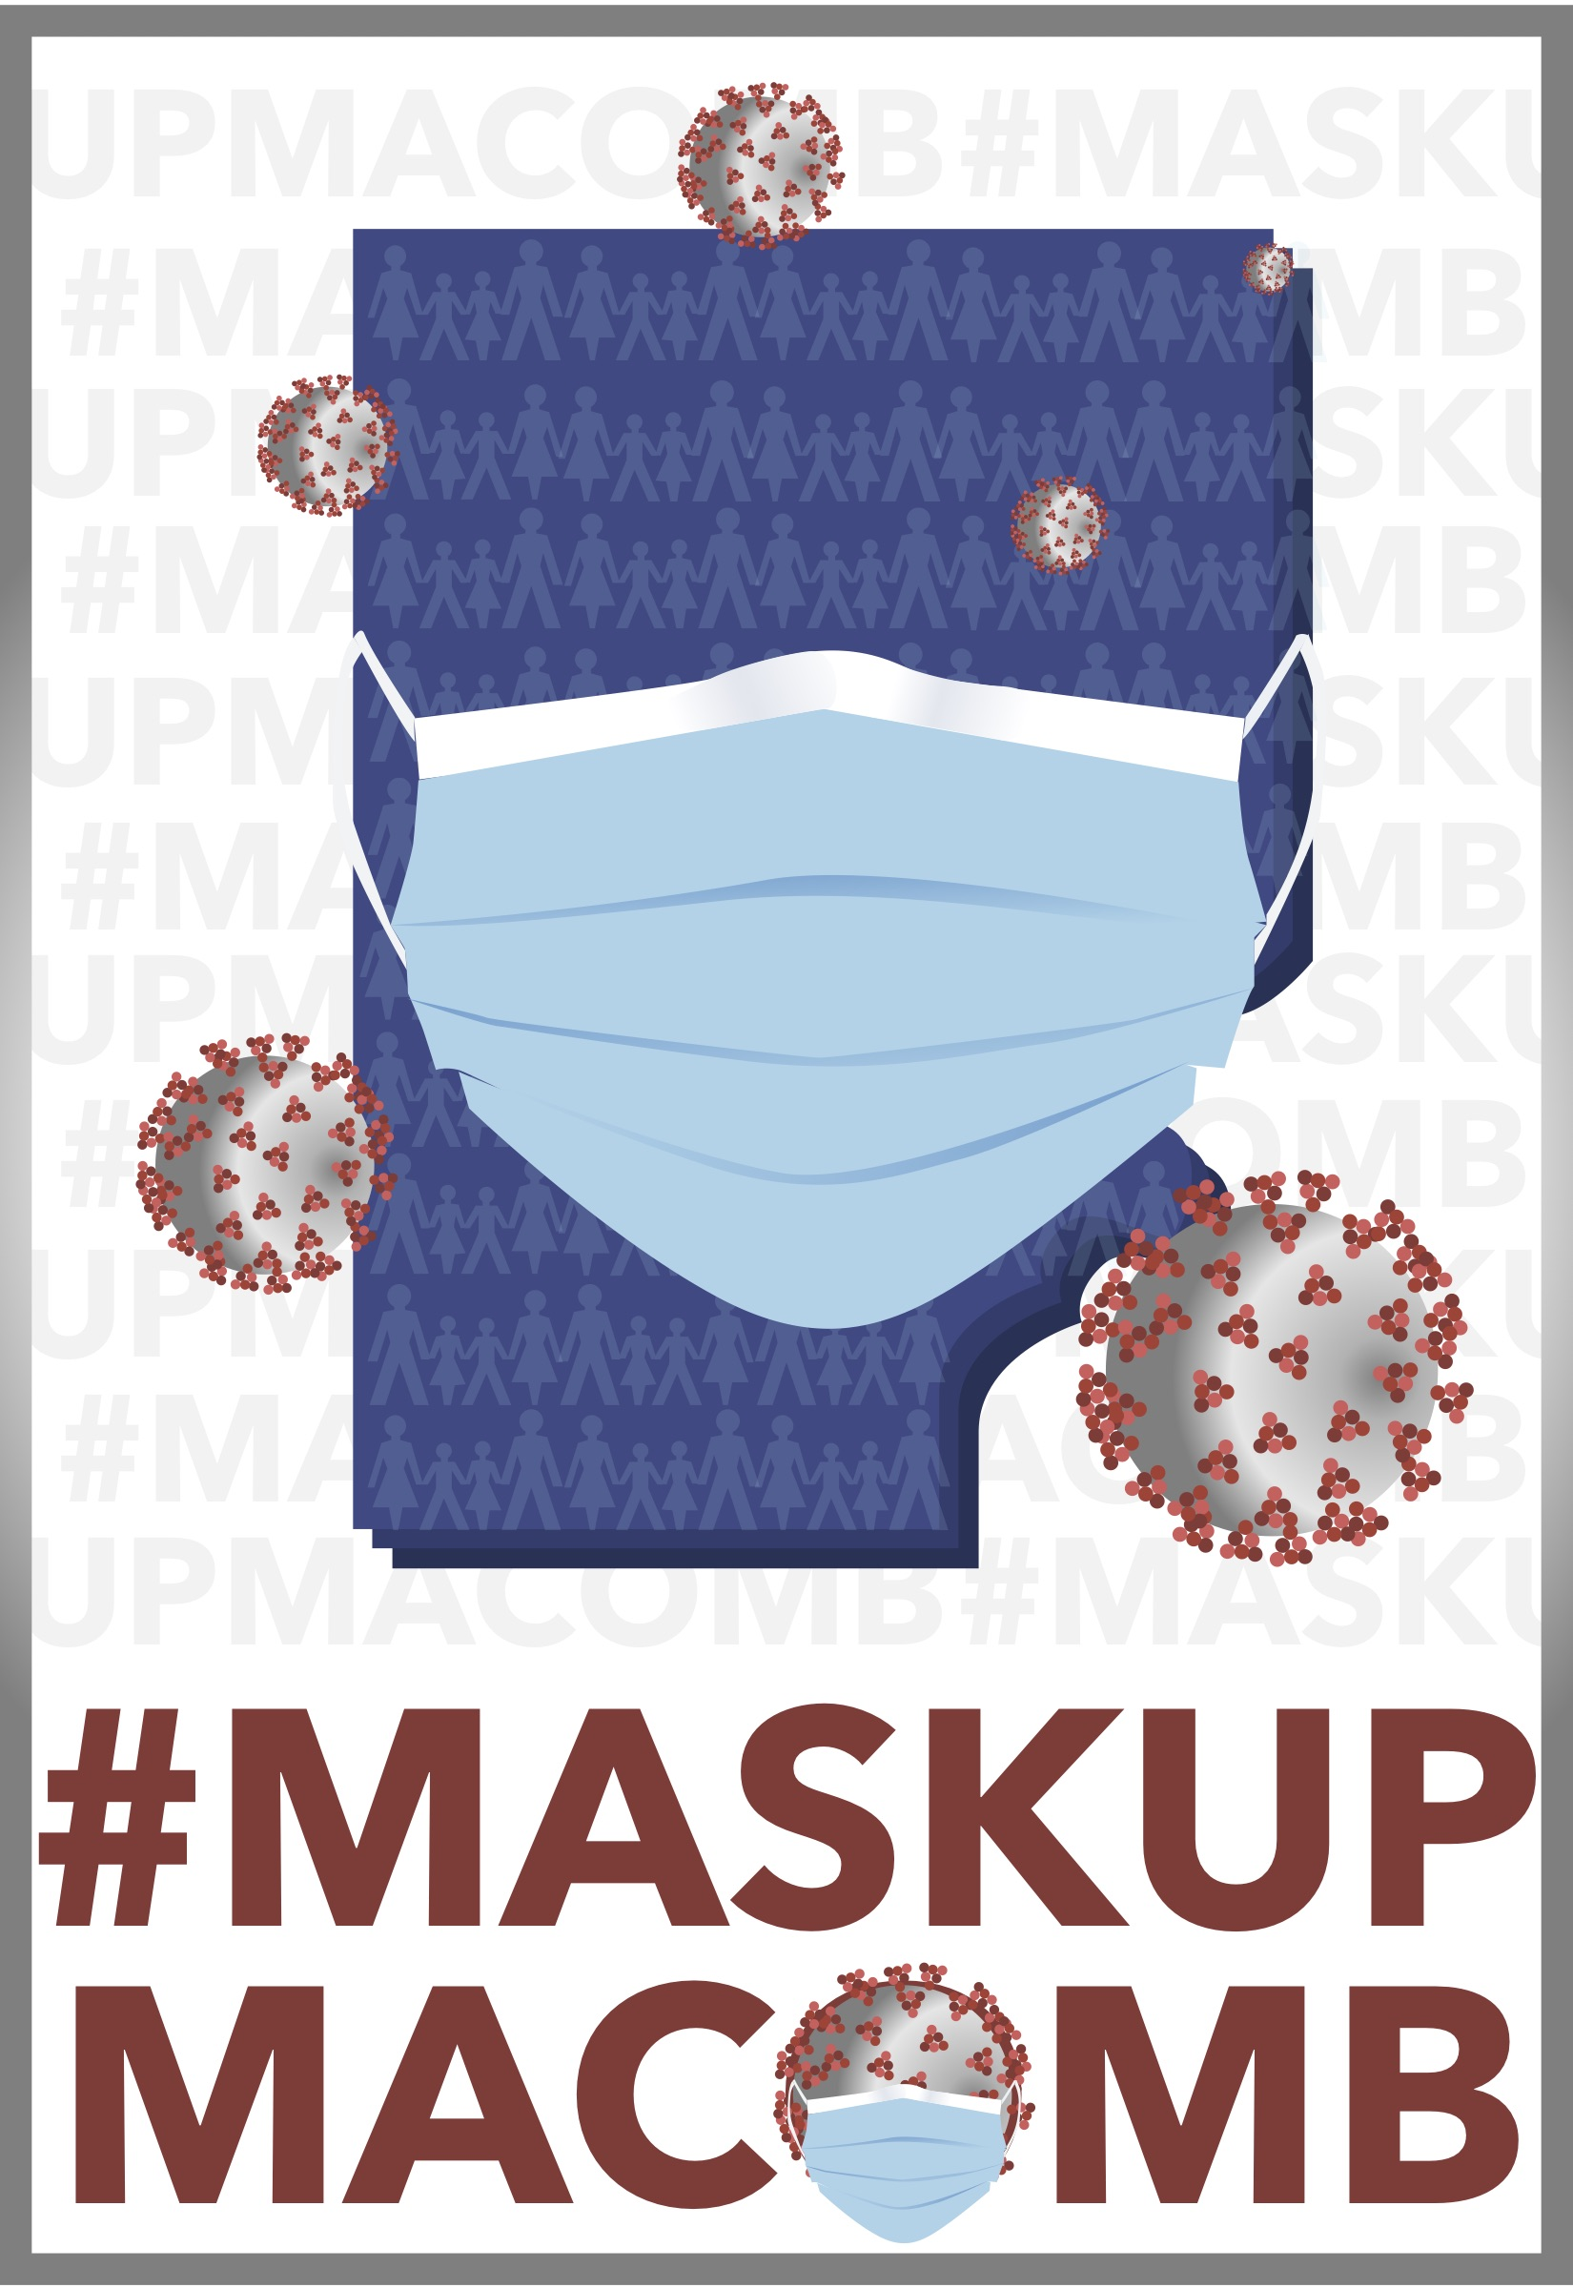  Third Place, Adult: Donna Hurt, "We Are Macomb", Digital art, from Sterling Heights, MI.

###

