November 17, 2022
IDEA COUNCIL INSTALLS PUBLIC ART AT ANTON ART CENTER

In 2020 the Anton Art Center recognized the need to make the arts community more accessible and inclusive of minority groups who were not equitably represented in the local arts community. In an effort to create change, the Inclusivity, Diversity, Equity, and Access (IDEA) Council was launched as an advisory body to help the Anton Art Center staff and Board of Trustees learn their way forward in efforts to be a more welcoming organization. One of the Council’s recommendations has culminated in the mounting of Mount Clemens’ newest public art installation: "Power" by Jay Hero, a large mural on the exterior of the Anton Art Center building with accompanying poem “Silence is a Sound” by award-winning poet Jessica Care Moore.

Long before the public art installation, the IDEA Council was actively engaging the community through a series of Community Conversations exploring topics like the importance of art in education or how art can help us have difficult conversations, and the series of Community Conversations centered around participants lived experiences with the arts community and the Anton Art Center. These conversations were held in a panel discussion format open to all members of the community and very specifically to provide a platform for dialog around the experiences of those who have traditionally been excluded or disenfranchised from the arts community. The Anton Art Center staff and board members were able to learn from people of color about how the arts community has and has not met their needs and, under the guidance of the IDEA Council, committed to a movement for change.

Detroit-based award-winning poet and musician Jessica Care Moore and graphic artist and Mount Clemens native Jay Hero worked to create both the mural “Power” and the poem “Silence is a Sound”. Both artworks are intended to create discussion in the community about underrepresentation in the arts, and champion the contributions of Black artists. Artists Jessica Care Moore and Jay Hero synthesized experiences and information from the Community Conversations as inspiration to represent the BIPOC community in both the poem and the 18' x 24’ public art installation which is now located on the west wall of the Anton Art Center’s modern addition.

To celebrate Mount Clemens’ newest mural, the IDEA Council will host a celebration at the Anton Art Center on December 8 at 6pm. This new mural represents an acknowledgement of the importance of all members of our community, and positive change toward inclusion and equity in the arts. Everyone is welcome to join the event as the Board of Trustees, IDEA Council, staff and volunteers of the Anton Art Center celebrate moving toward a better future.

You can find more information about the Anton Art Center by visiting www.theartcenter.org or calling 586-469-8666. The Anton Art Center is a registered nonprofit organization located in Mount Clemens, Michigan, with a mission to enrich and inspire people of all ages through the arts. The Anton Art Center is open for regular business hours Tuesday through Saturday from 10am-5pm; admission is free and open to the public. Metered lot and street parking is available; free on weekends.

To kick off the holiday season, The Anton Art Center is opening for the Holiday Market again this year from November 17 to December 23, 2022. The Anton Art Center will be filled with holiday decor and gifts for sale including fine art, unique handmade items, jewelry, ceramics, glass artworks, photographs and more. The Holiday Market hours are 11am-6pm on Tuesdays and Wednesdays, 11am to 8pm on Thursdays, 11am to 6pm on Fridays and Saturdays, and 11am to 3pm on Sundays. Additionally, on Sunday November 20th, they are hosting a Meet The Artists Reception that is open to the public from 1pm to 3pm. More information can be found on the Anton Art Center website.

The Anton Art Center (AAC) was founded in 1969 in the historic Carnegie Library building in walkable downtown Mount Clemens, Michigan. The AAC aims to build an open community around creative expression by presenting a wide array of programming to appeal to diverse audiences, providing support for the arts and becoming a focal point for arts programming, and working towards inclusion, diversity, equity, and access in all that we do to support our mission to enrich and inspire people of all ages through the arts.

Our funders include the Community Foundation for Southeast Michigan, the Kresge Foundation, Michigan Council for Arts & Cultural Affairs, and the National Endowment for the Arts.

###

IDEA Council Mural “Power” by Jay Hero
Photos courtesy of the Anton Art Center
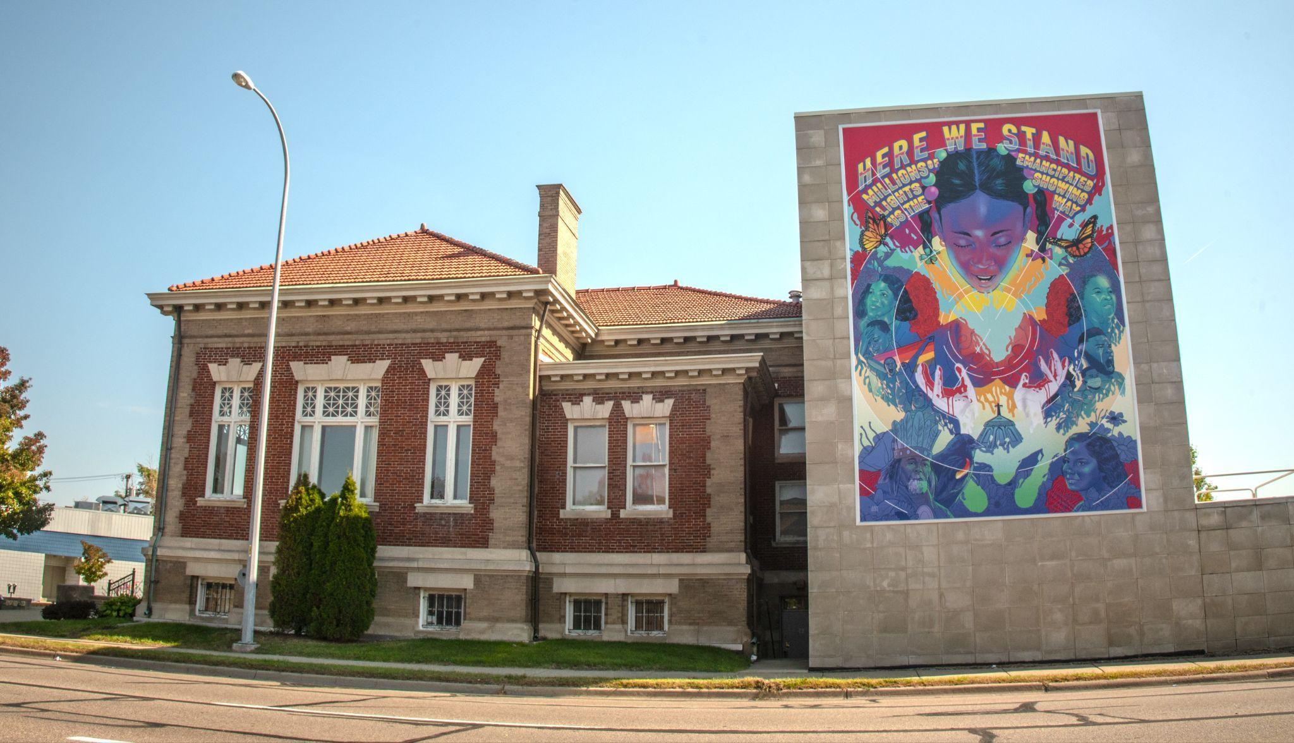 | 



