Reception Host Invitation

Thank you for your interest in hosting a reception event at the Anton Art Center! We have many opportunities to participate as a host throughout the year.

Exhibition receptions usually last around two hours and attract many artists and art supporters. Our gallery admission is free year-round and our events are open to the public; donations are accepted. A typical attendance for a group exhibition is around 125 people. Attendance for one of our student shows can reach up to 500 visitors.

The Art Center can provide tables, tablecloths, assortment of serving platters, and punch bowl, and paper goods, such as cups, napkins, and plates. Our reception host is responsible for the refreshments, such as mini water bottles, punch, sparkling water, cookies, bite-size hors d'oeuvres or desserts, cheese and crackers, fruit and/or vegetable tray, and any other combination of items.

In 2019, the Anton Art Center celebrates fifty years as Macomb County's leading non-profit art organization housed in an original historic Carnegie Library building built in 1904, in Downtown Mount Clemens, Michigan. Parking is available by street or meter lot; free after 6pm and on weekends.

Thank you for your consideration! Your interest in supporting the local arts in your community is valuable and appreciated. Please contact us with any questions or concerns. Should you be interested in signing up for an opportunity, please complete and submit the ‘Reception Host Application’ (page 4) when convenient.

Sincerely,

Stephanie Hazzard
Exhibition Manager
(586) 469-8666
sahazzard@theartcenter.org

Reception Host Photos
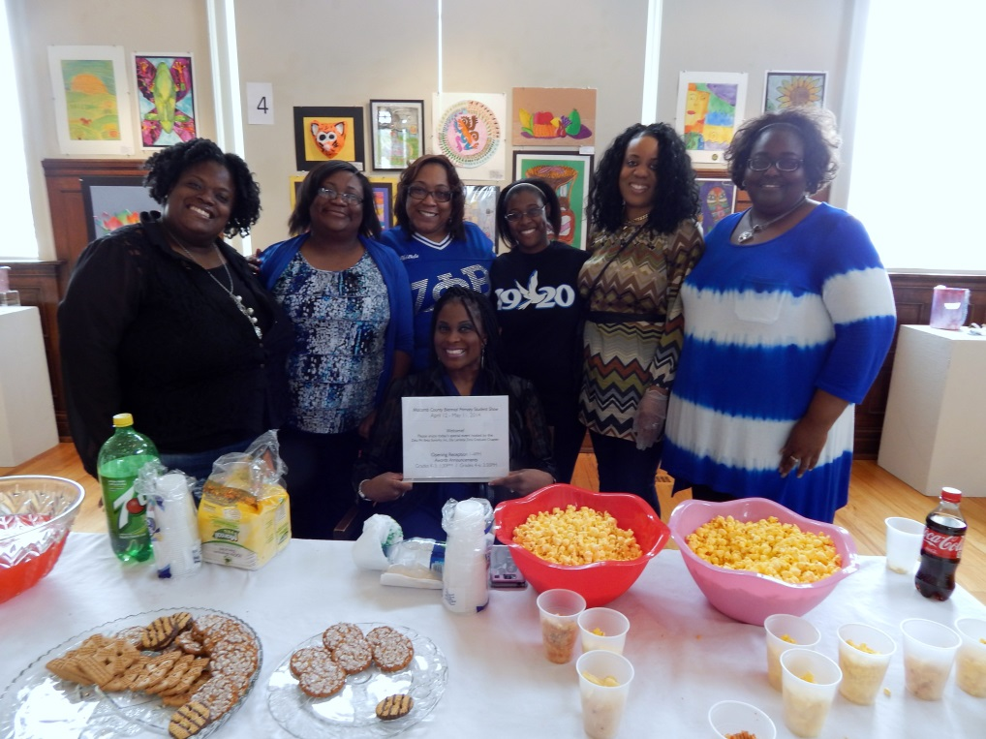

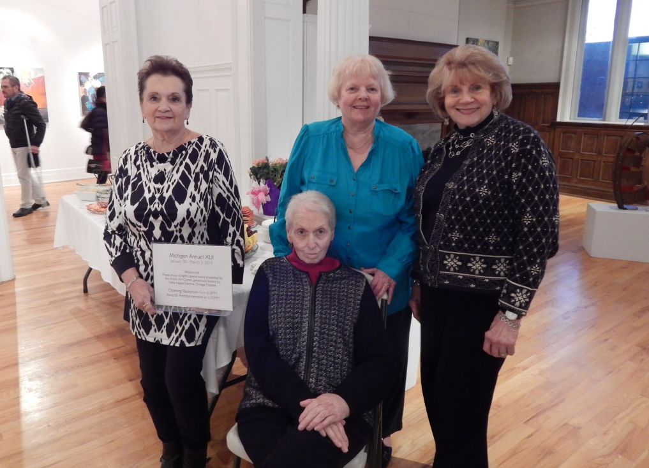

Volunteer Exhibition Reception Host Application

Host Organization or Group Name ________________________________________________________

Contact Name _______________________________________Title _____________________________

Address ____________________________________________________________________________

City __________________________ State Zip _________Phone____________________

E-Mail Address_______________________________________________________________________

□ Please contact me, I/my group would like to host a reception event.

Event ______________________________________________________________________________

Date ___________________________________________Time________________________________

□ Unsure

Volunteer Exhibition Reception Host Contract

Event: ___________________________________________ Date & Time: _______________________

Host Organization ___________________________ ______________________________________

Contact Name ______________________________________ Title _________________________

Address ____________________________________________________________________________

City _________________________ State _____________ Zip __________ Phone_________________

E-Mail Address_______________________________________________________________________

Alternate Contact _____________________________________ Title ________________________

Address ____________________________________________________________________________

City _________________________ State _____________ Zip __________ Phone_________________

E-Mail Address_______________________________________________________________________

Host Responsibilities & Suggestions: To supply and serve punch/lemonade/other beverage, mini water bottles, and hors’doeuvre- or bite-sized appetizers, including, but not limited to the following: cookies, treats, vegetables and dip, fruit, cheese and crackers, or other chosen snack item or combination of items. Any plastic ware, toothpicks, food labels, flowers, table decorations, etc. Must have at least two volunteers and stay for the duration of the event. Please plan for about 150 guests, unless otherwise discussed. Optional: Linens, small napkins, small plates, small cups, platters, punch bowls, etc.

The Anton Art Center will identify the host in print and digital publicity for the event. They will also provide any or all of the following, if requested: tables, linens, signage, small napkins, small plates, small cups, platters, punch bowls, and chairs.

Host Representative Signature ___________________________________ Date __________________

Anton Art Center Representative _________________________________ Date __________________

Please complete and return this form by mail, email, or fax to Stephanie Hazzard, Exhibition Manager, at your earliest convenience in order to have your group’s name included in the event publicity.

