June 17, 2021
ANTON ART CENTER ANNOUNCES HERE COMES THE SUN EXHIBITION

Anton Art Center is proud to present Here Comes the Sun, opening on June 26, 2021. This exhibition consists of 42 selected artworks by 34 artists from the Detroit Society of Women Painters and Sculptors. Founded in 1903, the Detroit Society of Women Painters and Sculptors is one of the oldest women’s art organizations in the United States. The exhibition Here Comes the Sun is juried by Richard Reeves, Jr., Director of Arts & Culture at the Kayrod Gallery at the Hannan Center in Detroit.

The exhibition is a collection of how various members of the Detroit Society of Women Painters and Sculptors (DSWPS) let the sun shine through their artwork. "As a new member of DSWPS, I am honored to be included in this exhibit. In keeping with the theme of work completed during quarantine, my little painting was a part of a 'Get Well & Support' series,” says artist Tudi Harwood, “During the pandemic and house-bound, I began looking at ordinary things in my home that gave me comfort in the chaos. The ordinary became extraordinary during isolation. Supporting my family and friends through beautiful images helped pass the months of worry for us.”

For many of the artists, the pandemic played a critical role in inspiring their work. Artist Kimberly Santini shares, “The Detroit Society of Women Painters and Sculptors provides a direct connection between me and the deep history of women artists in Detroit. The group provides community, inspiration, and opportunity to its membership. After a year of gathering remotely--together, but apart--we are looking forward to a post-pandemic future for women in the arts in Detroit, and it starts with this exhibition.”

Artworks will be on display in the Main Floor Galleries, as well as virtually on the Anton Art Center’s website (www.theartcenter.org/exhibits). For the safety of staff, volunteers, members, artists, and visitors, the Anton Art Center will host a Virtual Awards Announcement on Saturday, June 26th at 2:00pm. The event will be streamed live on the Anton Art Center Facebook page and is open to all. Here Comes the Sun will be on display in-person and virtually through August 17, 2021.

For more information about the Anton Art Center, visit www.theartcenter.org or call 586-469-8666. The Anton Art Center is a registered nonprofit organization located in Mount Clemens, Michigan, with a mission to enrich and inspire people of all ages through the arts. The Anton Art Center is open Tuesday through Saturday from 11am until 3pm; admission is free and open to the public.

###

Here Comes the Sun
Sample images of exhibiting artwork.

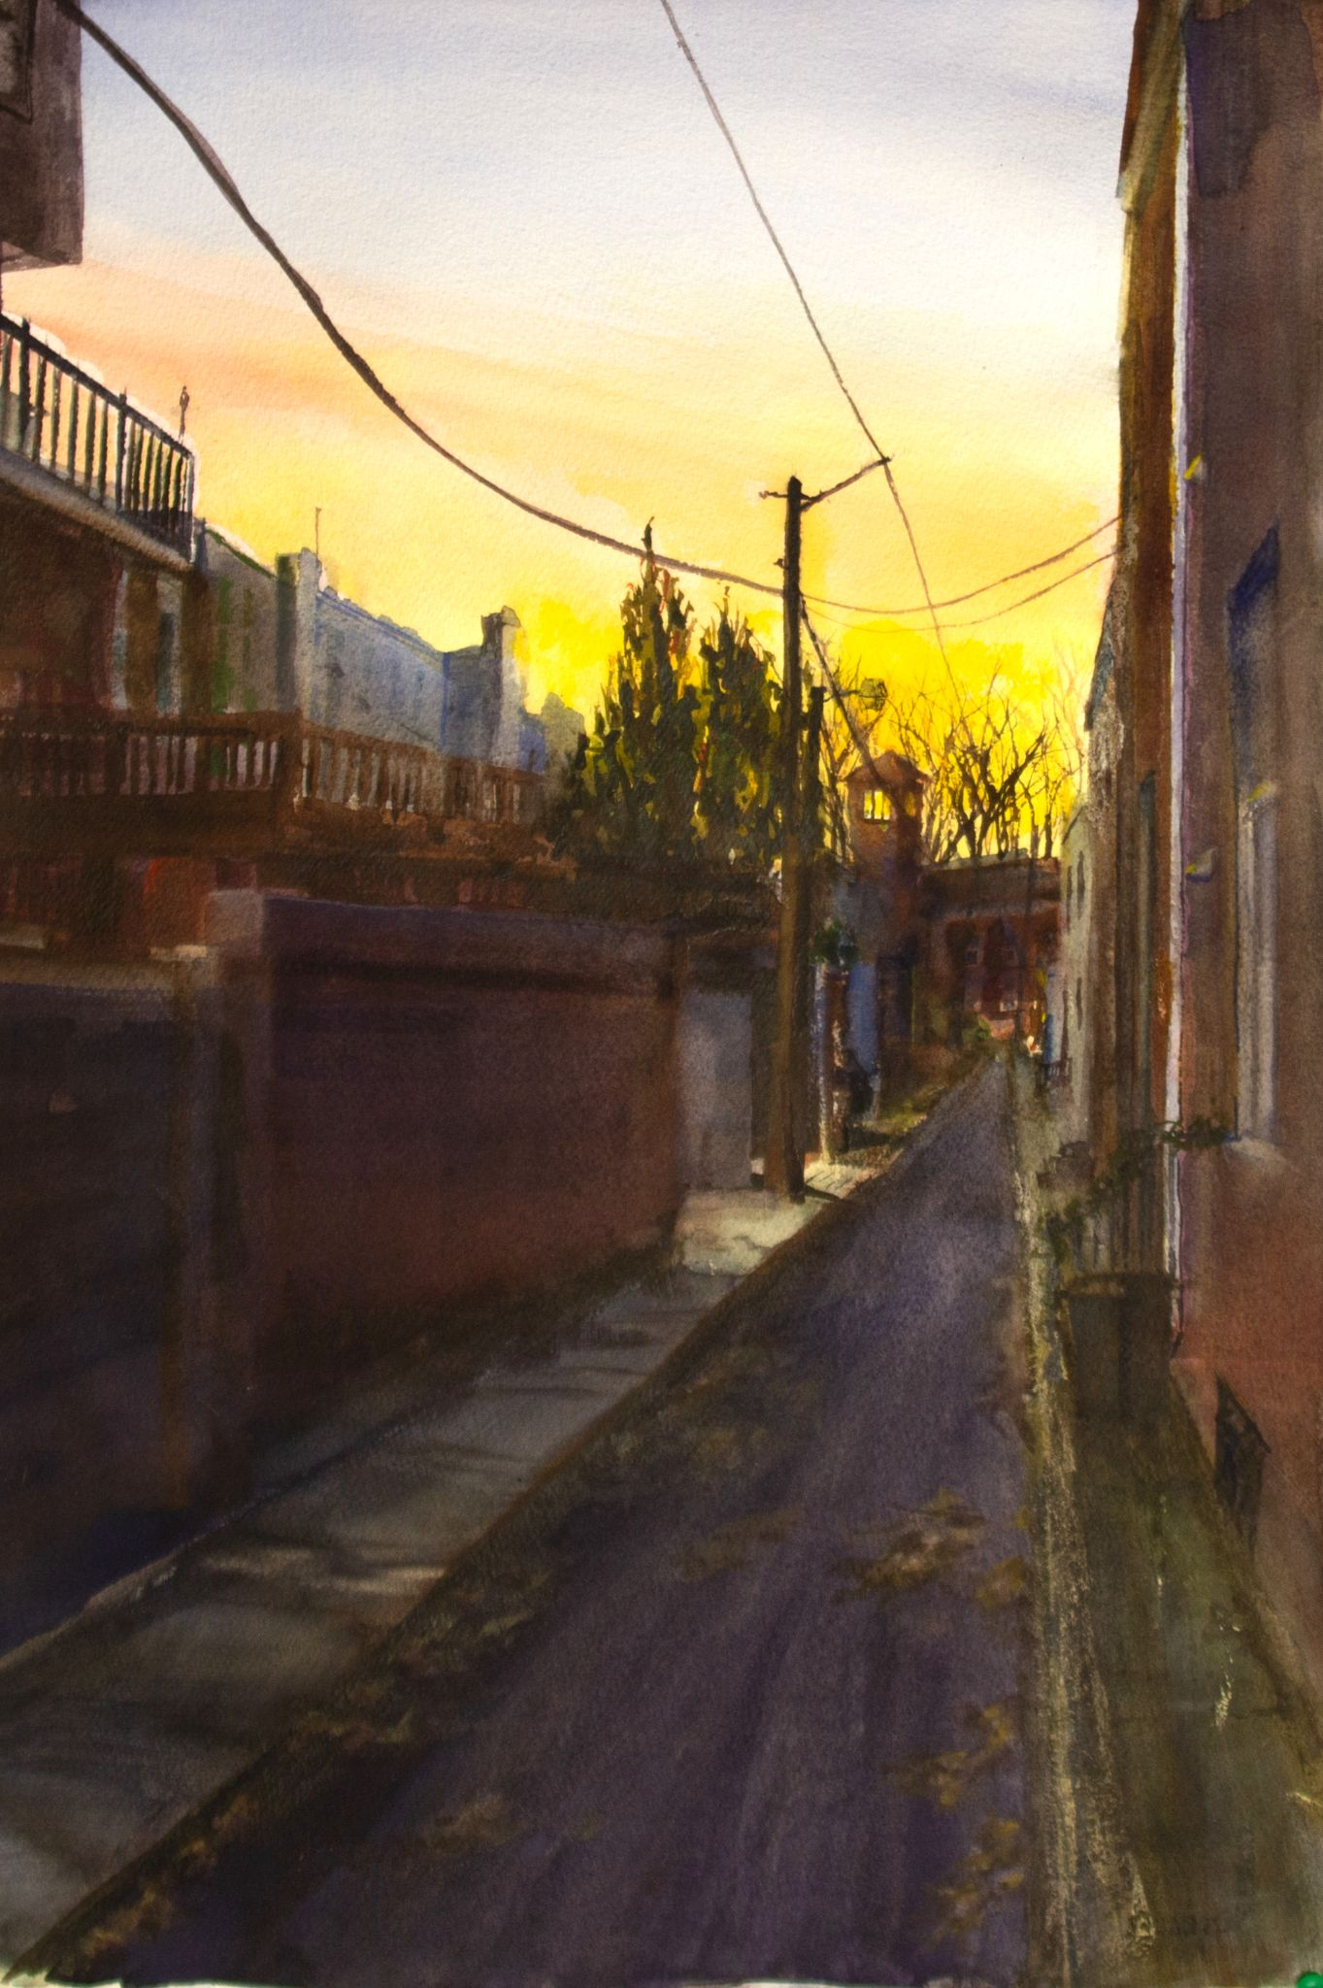  Illuminated Alley, Watercolor  Kathleen McNamee, Detroit Society of Women Painters and Sculptors | 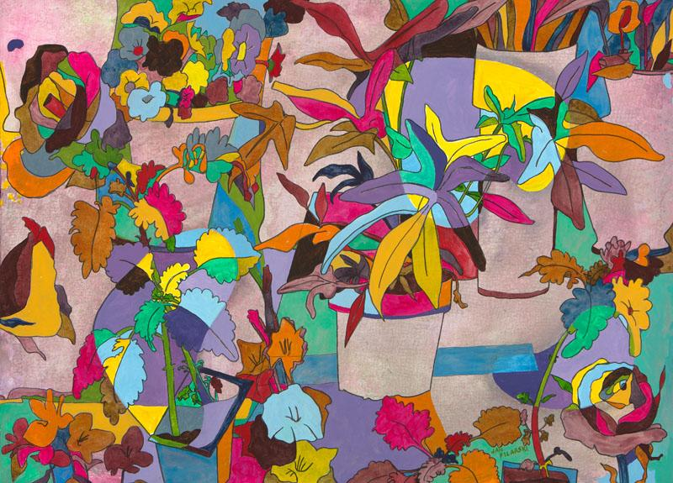  A Jumble of Pots, Water media  Jan Filarski, Detroit Society of Women Painters and Sculptors
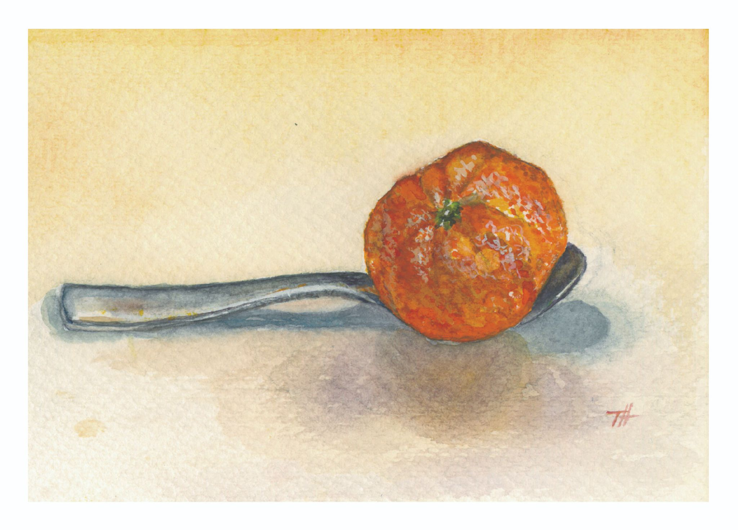  The Cure, Watercolor  Tudi Harwood, Detroit Society of Women Painters and Sculptors | Rhapsodic, Mixed media  Vasundhara Tolia, Detroit Society of Women Painters and Sculptors
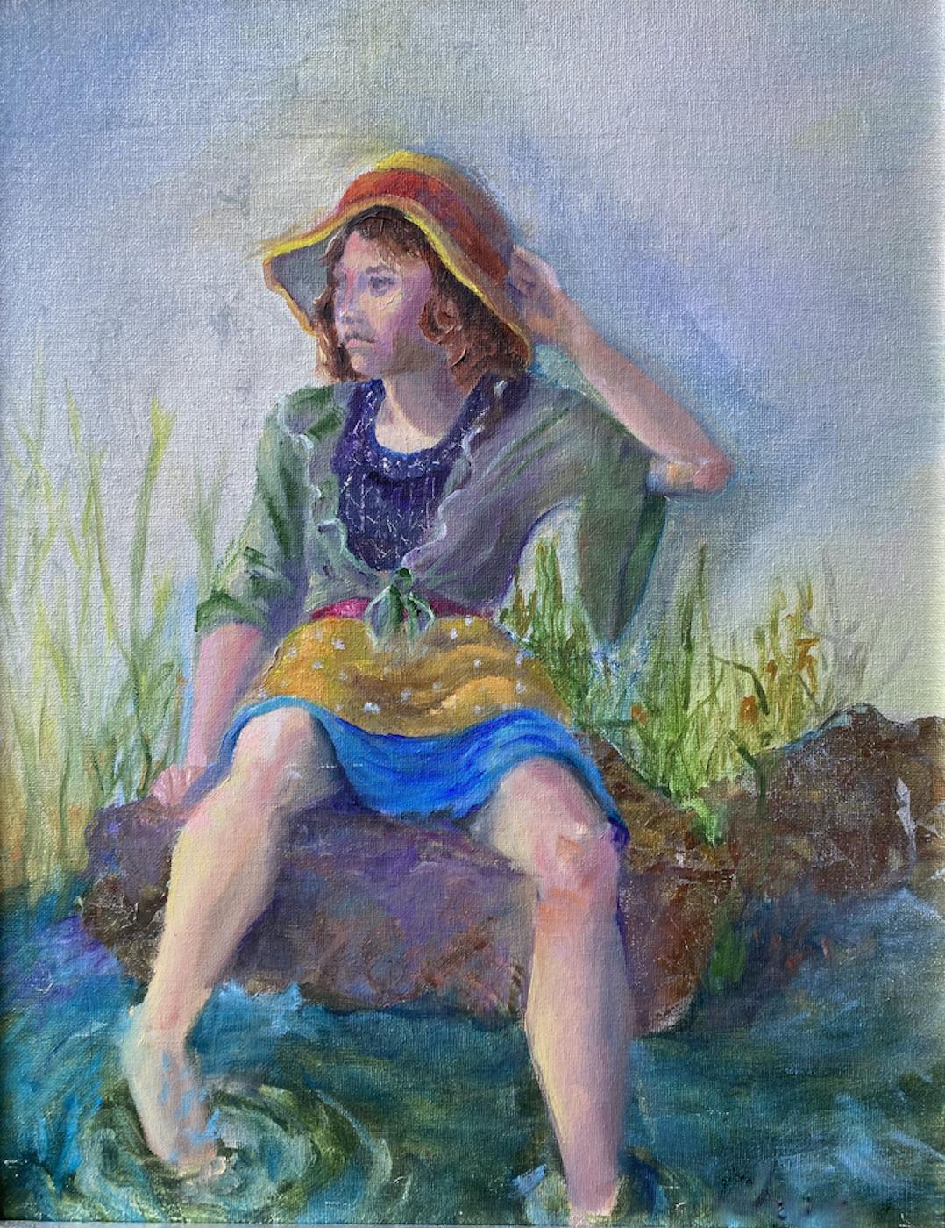 | 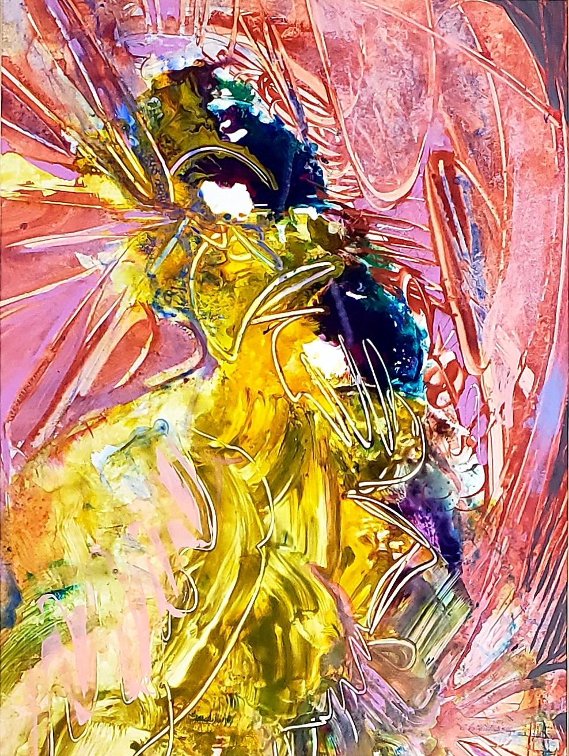
Peaceful Solitude, Mixed media  Lynn Edwards Newman, Detroit Society of Women Painters and Sculptors | FAITH, Acrylic paint  Linda Allen, Detroit Society of Women Painters and Sculptors

###

