April 11, 2023

ANTON ART CENTER ANNOUNCES HONORARY CHAIRS FOR 2023 ARTPARTY

Mount Clemens, MI - Anton Art Center, a nonprofit organization with a mission to enrich and inspire people of all ages through the arts, has announced the Honorable Mark Switalski (Retired) and Former Judge Jodi Debbrecht Switalski as Honorary Chairs for the 2023 ArtParty. Presented by First State Bank, the event will take place on September 21 from 6pm to 9pm at the Anton Art Center, is the organization's largest fundraising effort of the year.

This year's ArtParty theme is "Express Yourself," and the theme color is Viva Magenta. The event will feature a variety of entertainment options, including live music, art demonstrations, and hands-on art experiences which showcase the work the Anton does across Macomb County.

"We're thrilled to have the Honorable Jodi and Mark Switalski as our Honorary Chairs for this year's ArtParty event," said Phil Gilchrist, Executive Director of Anton Art Center. "Their commitment to the arts and the community is an inspiration to us all, and we're grateful for their support."

Mark and Jodi Switalski also share their excitement for the 2023 ArtParty, "The Anton Art Center plays a significant role in the cultural and economic life of Mount Clemens and the surrounding area. We are incredibly lucky to have this iconic space that promotes the arts through events, exhibitions and engagement in our community. We are proud to be a part of the 2023 event"

The Anton Art Center's ArtParty event is a highly anticipated evening of food, entertainment, and art, where people can celebrate and mingle while acknowledging the value art has in our lives. The event draws supporters of the Anton Art Center, community members, and civic leaders from across Macomb County. Proceeds from the event support the Anton Art Center's programs. Tickets for the 2023 ArtParty event will be available for purchase beginning in August.

Art plays an important role in our communities by enriching people's lives, promoting creativity and self-expression, fostering cultural understanding and appreciation, and enhancing community development. Studies have shown that engagement in the arts can have positive effects on mental health, cognitive development, and overall wellbeing. Art can also be a powerful tool for social change, as it allows individuals and communities to explore important issues and express themselves in new and meaningful ways. Additionally, the arts have been shown to have a positive impact on local economies by attracting tourists, creating jobs, and supporting small businesses. The Anton Art Center's ArtParty event not only provides a fun and engaging way for people to support the arts, but also helps to raise awareness of the important role that art plays in our communities.

For questions or information, visit www.theartcenter.org or call 586-469-8666. The Anton Art Center is a registered 501(c)(3) nonprofit organization located at 125 Macomb Place, Mount Clemens, Michigan, with a mission to enrich and inspire people of all ages through the arts. The Anton Art Center is open for regular business hours Tuesday through Saturday from 10am-5pm; admission is free and open to the public, and the facility is handicap accessible. Metered lot and street parking is available; free parking on weekends.

The Anton Art Center (AAC) was founded in 1969 in the historic Carnegie Library building in walkable downtown Mount Clemens, Michigan. The AAC aims to build an open community around creative expression by presenting a wide array of programming to appeal to diverse audiences, providing support for the arts and becoming a focal point for arts programming, and working towards inclusion, diversity, equity, and access in all that we do. Our mission is to enrich and inspire people of all ages through the arts. Our funders include the Community Foundation for Southeast Michigan, the Kresge Foundation, Michigan Arts and Culture Council, the Erb Family Foundation, and the National Endowment for the Arts.

###

Photos Courtesy of Anton Art Center

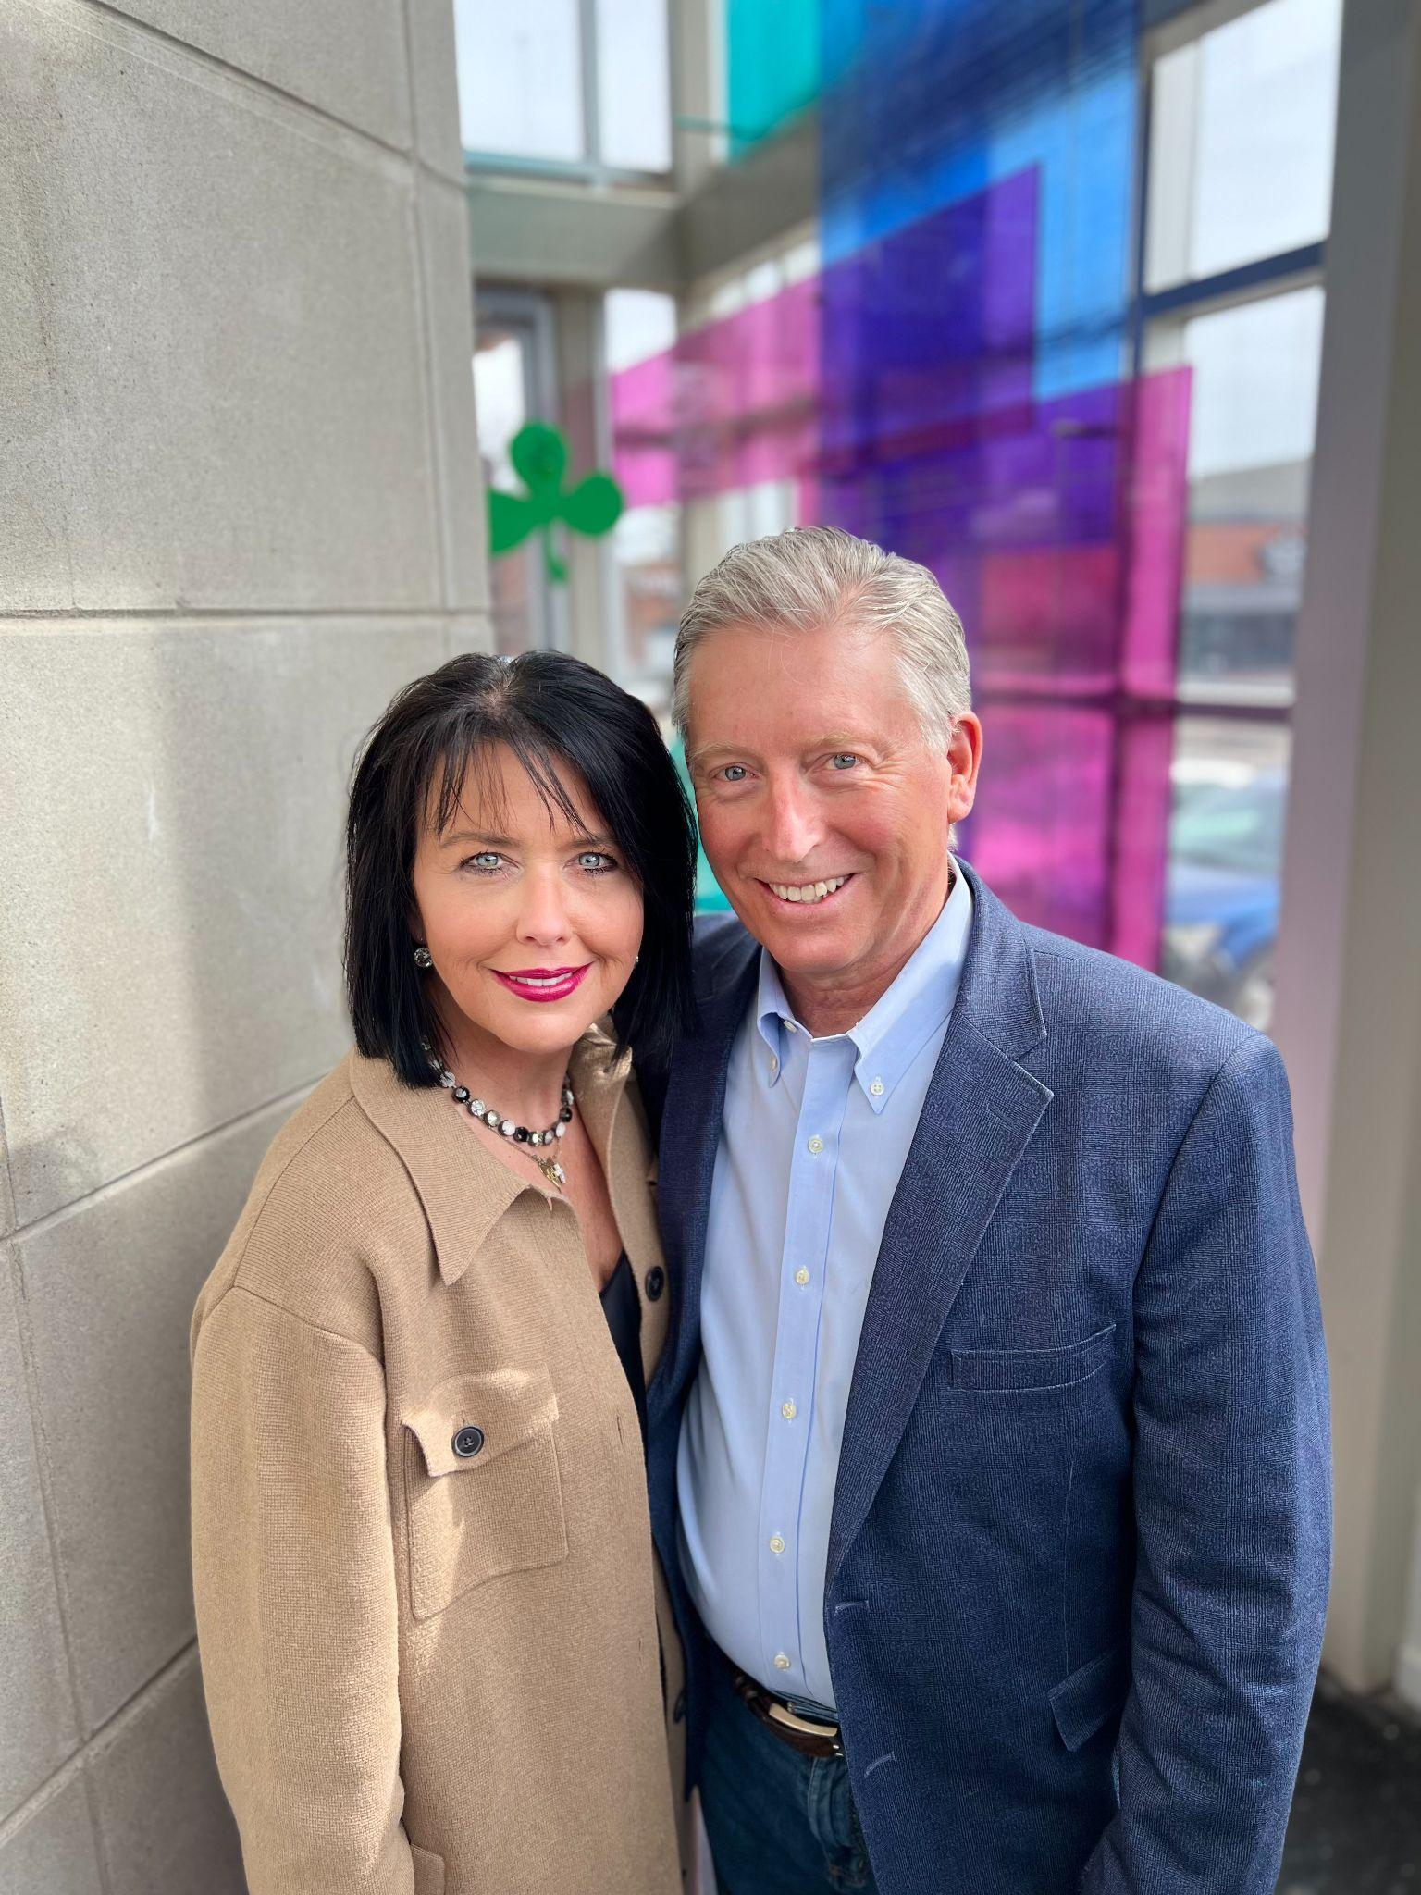
Honorable Mark Switalski (Retired) and Former Judge Jodi Debbrecht Switalski
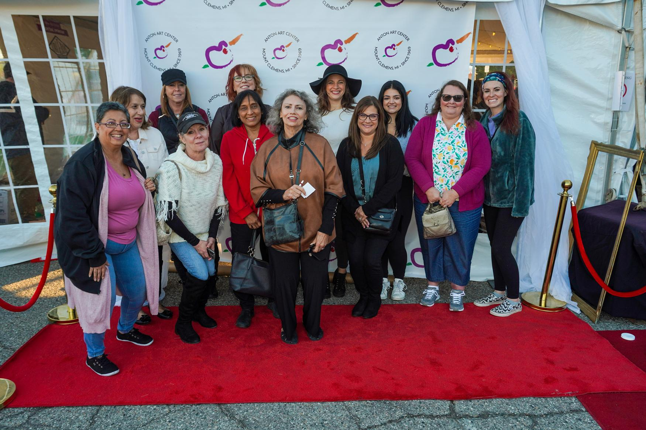  2022 ArtParty | 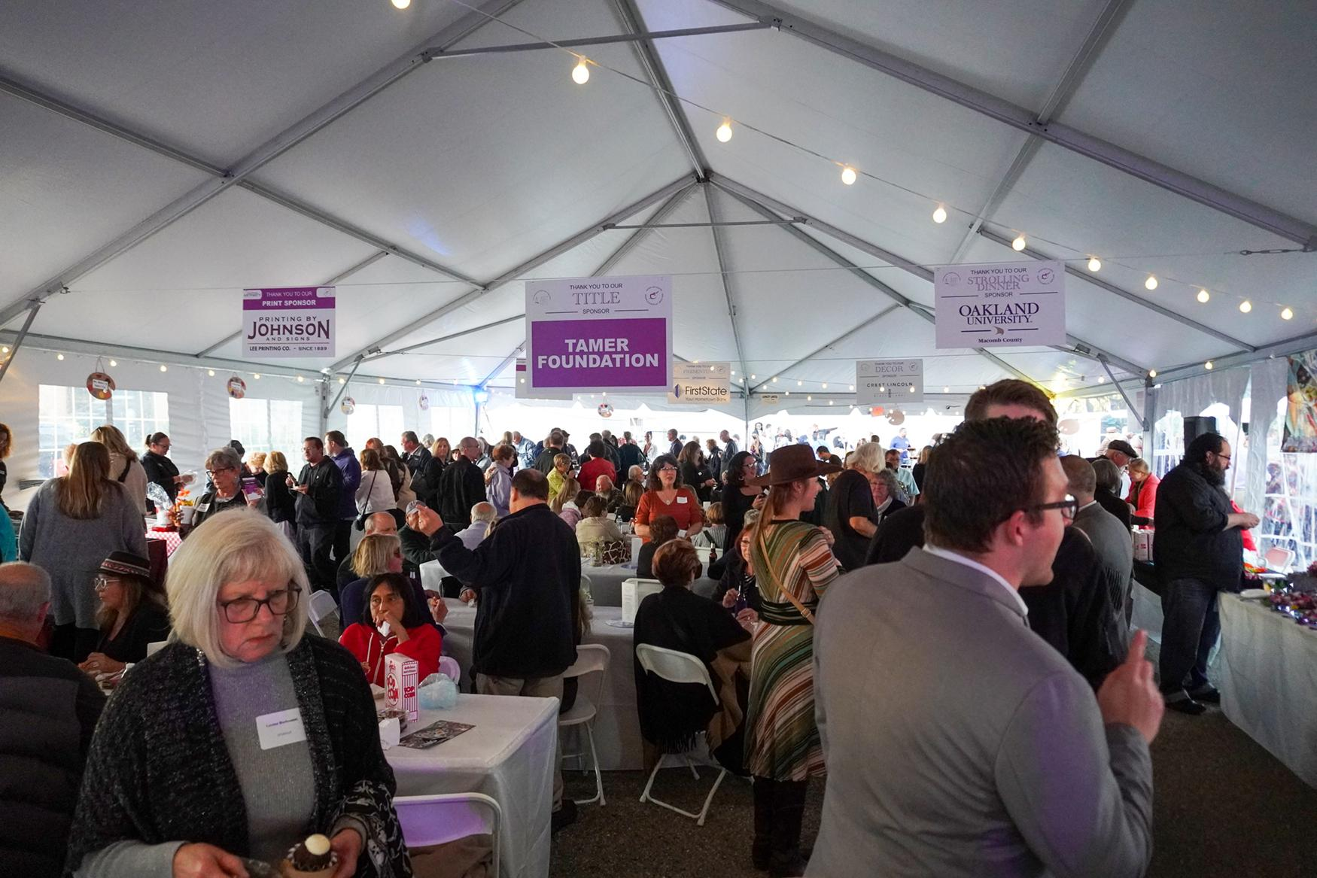  2022 ArtParty
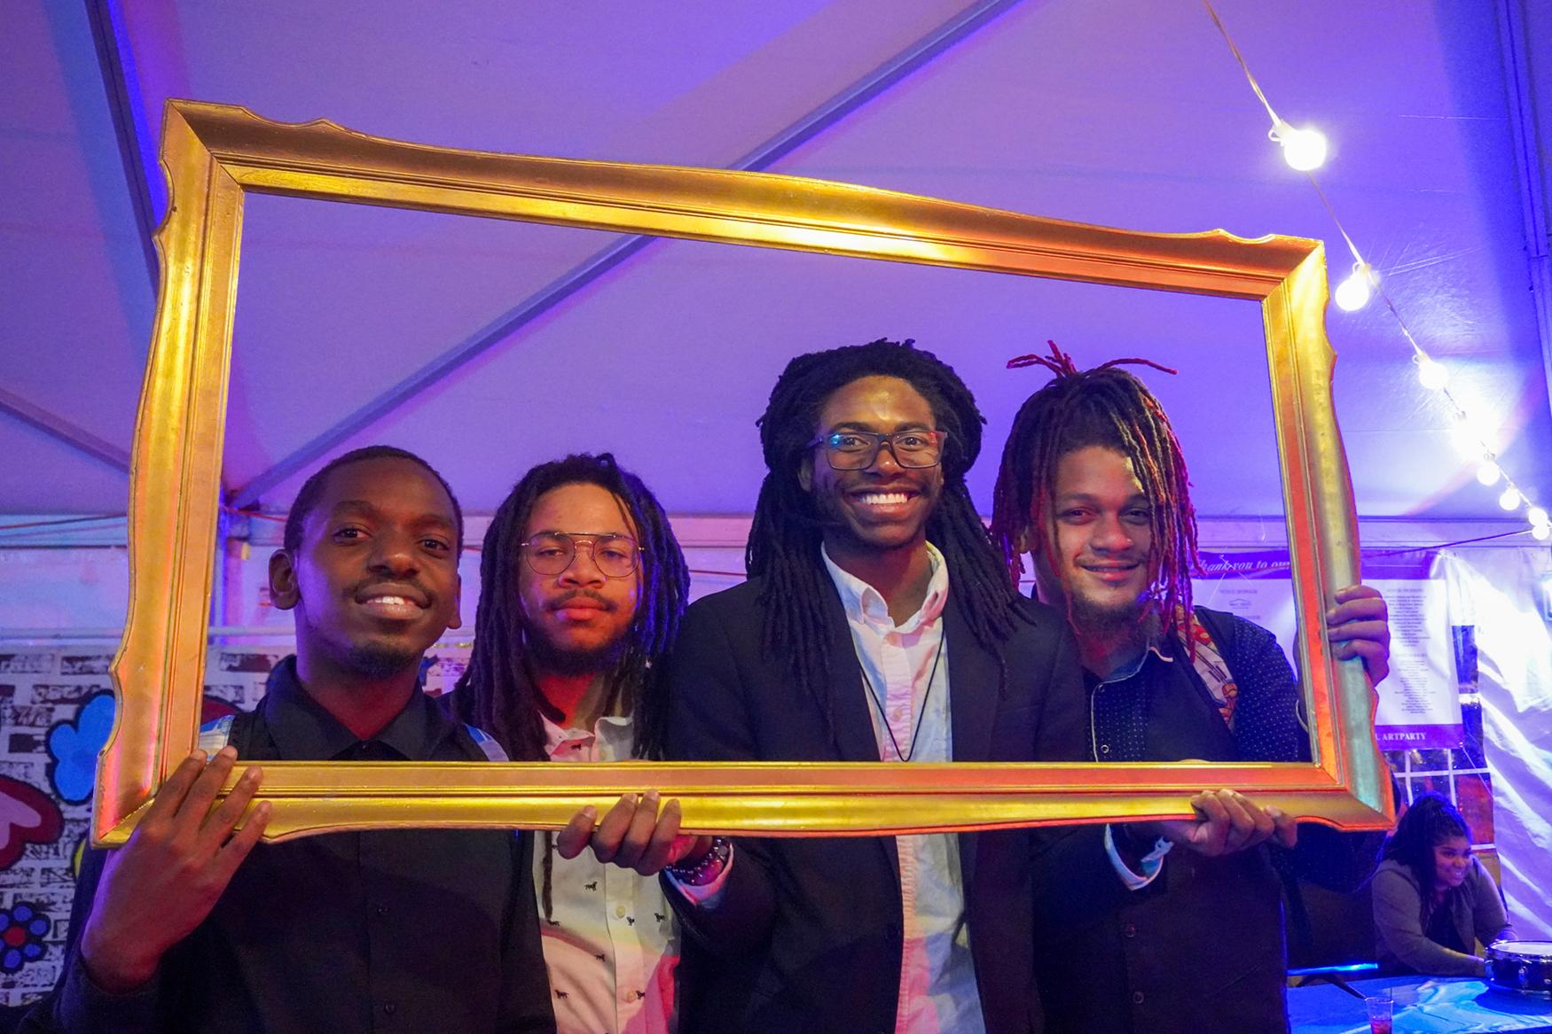  2022 ArtParty | 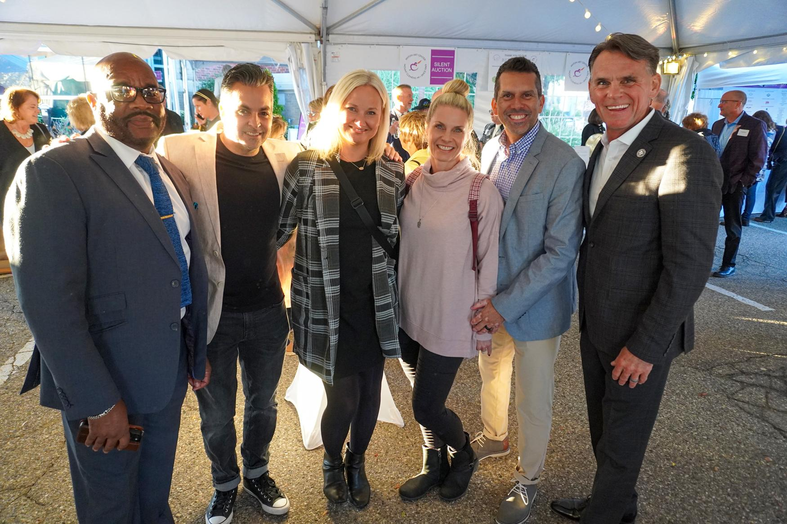  2022 ArtParty

###

